**1. Connect two hosts back-to-back with a cross over cable. Assign IP addresses, and see whether they**

**are able to ping each other.**

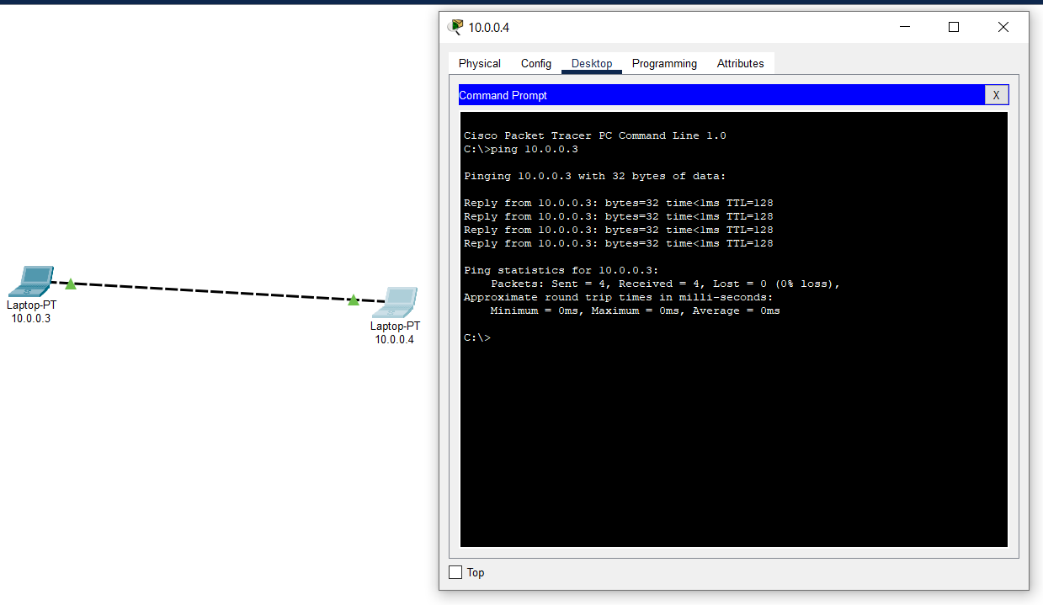

**2. Create a LAN (named LAN-A) with 3 hosts using a hub. Ping each pair of nodes.**

**Ip Assigned – 192.168.0.4, 192.168.0.4, 192.168.0.6.**

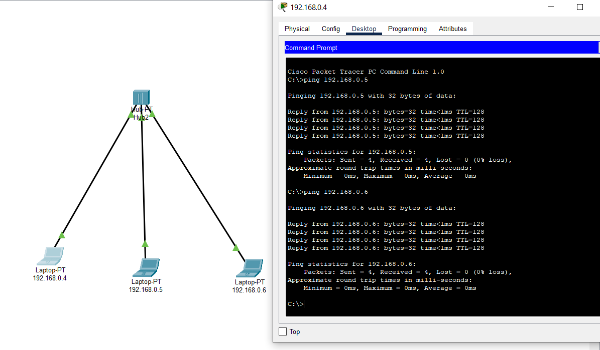

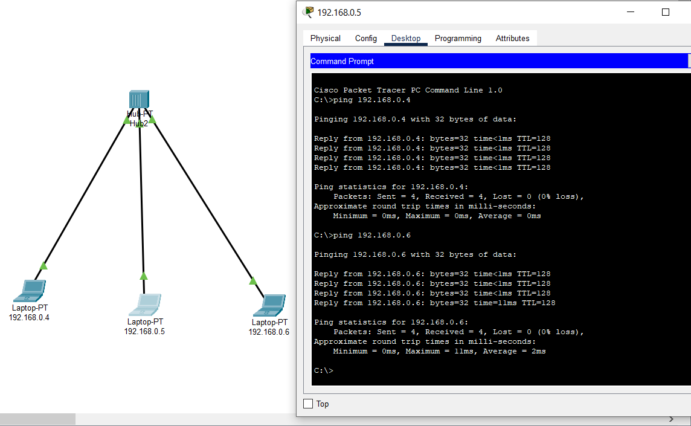

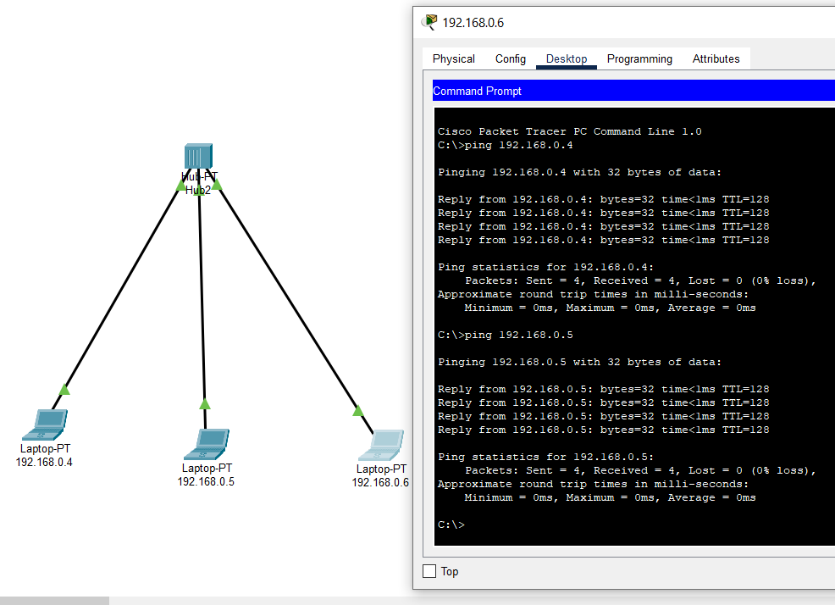

**3. Create a LAN (named LAN-B) with 3 hosts using a switch. Record contents of the ARP Table of end**

**hosts and the MAC Forwarding Table of the switch. Ping each pair of nodes. Now record the**

**contents of the ARP Table of end hosts and the MAC Forwarding Table of the switch again.**

**Ip Assigned – 192.168.0.1, 192.168.0.2, 192.168.0.3.**

**Initially Mac and ARP table empty**

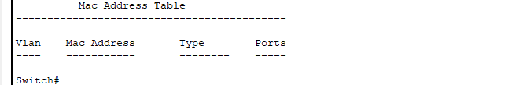

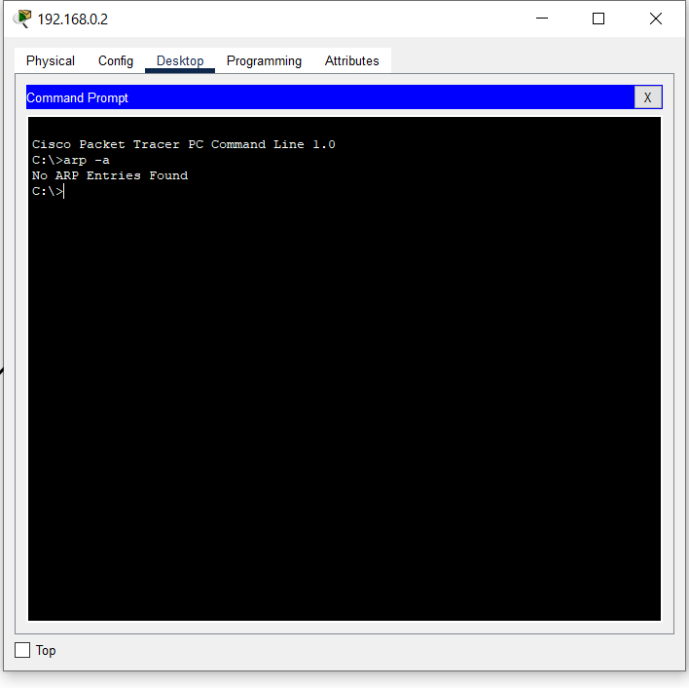

**After pairwise pinging ARP entries**

**For 192.168.0.1**

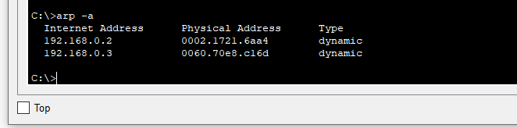

**For 192.168.0.2**

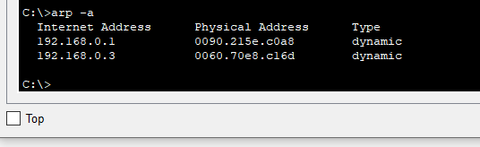

**For 192.168.0.3**

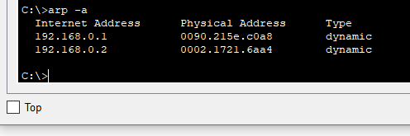

**MAC forwarding table**

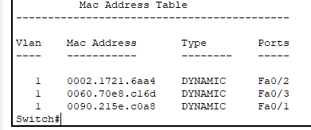

**4. Connect LAN-A and LAN-B by connecting the hub and switch using a cross-over cable. Ping between**

**each pair of hosts of LAN-A and LAN-B. Now record the contents of the ARP Table of end hosts and**

**the MAC Forwarding Table of the switch again.**

**For 192.168.0.1**

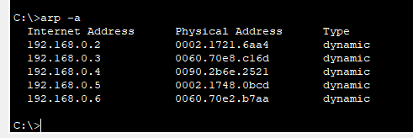

**For 192.168.0.2**

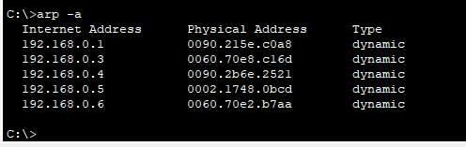

**For 192.168.0.3**

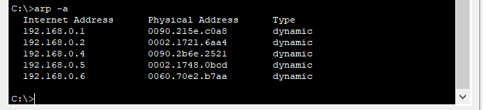

**For 192.168.0.4**

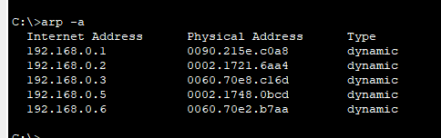

**For 192.168.0.5**

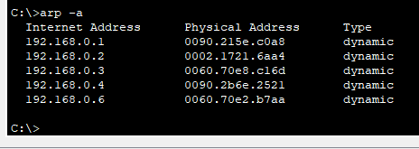

**For 192.168.0.6**

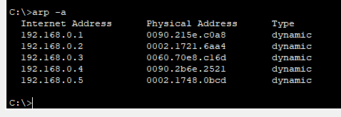

**MAC forwarding Table**

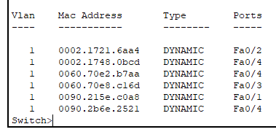

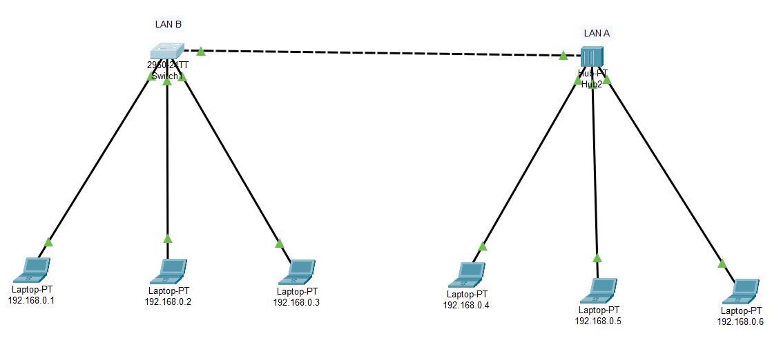

**5. Create a LAN (named JU-Main) with three hosts connected via a layer-2 switch (Cisco 2950 switch**

**PC-LAB1-Switch). Connect the switch to a router (Cisco 1818). Assign IP addresses to all the hosts**

**and the router interface connected to this LAN from network 192.168.148.0/24. Configure default**

**gateway of each hosts as the IP address of the interface of the router which is connected to the LAN.**

**Create another LAN (named JU-SL) with three hosts connected via a layer-2 switch (Cisco 2950**

**switch PC-LAB2-Switch). Connect this switch to another router (Cisco 1818). Assign IP addresses to**

**all the hosts and the router interface connected to this LAN from network 192.168.149.0/24.**

**Configure default gateway of each hosts as the IP address of the interface of the router which is**

**connected to the LAN. Connect the two routers through appropriate WAN interfaces. Assign IP**

**addresses to the WAN interfaces from network 192.168.150.0/24. Add static route in both of the**

**routers to route packets between two LANs.**